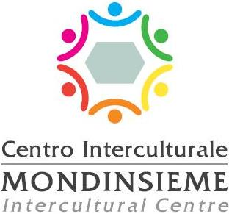

**Politiche per l’Intercultura**

**Per contatti:** 0522-456756 / 585048 / 585468



**REGISTRATION FORM AMONG THE SCHOOL DESKS IN SUMMER (TRA I BANCHI D’ESTATE) 2025**

Surname and name………………….…………………………………………

M  F 

Place and date of birth…………………………………………………………

Tax ID code …………………………………………………………………….

Address…………………………………………………………………………..

Student telephone number………………………………………………………

Parent telephone number ………………………….…………………………..

Mother tongue/Native language…………..……………………………………

Other ​​studied languages …………………………………….…………………

Date of arrival in Italy…………………………………………………………

Any Italian L2 course attended in Italy

Yes  No 

If yes, where? …………………………………………………………………….

* number of years attended outside Italy ……………………………………………………
* schools attended in Italy …………………………………………………….

School in which you intend to enroll for the 2025 – 2026 school year ……………………………………………………..……..…..……..…………...

Currently enrolled in class _______________________

#### **AUTHORIZATION FOR ATTENDANCE AND VIDEO DOCUMENTATION**

### Reggio Emilia, ____________________

##### I, the undersigned_____________________________________________________

Parent or guardian of _____________________________________

# **I authorize**

my son/daughter to participate in the Italian language summer course organized by the Municipality of Reggio Emilia and the Mondinsieme Foundation.

Signature

________________

I also authorize any videos - documentation of the activity, short educational trips and the processing of data connected solely to the institutional activities of the Municipality of Reggio Emilia.

Signature

**NB: Please send the completed application to: intercultura@comune.re.it**

For Information, Intercultura Office, Tel. 0522-585468 or 0522–456756 or 0522-585048